WECC Child Safe Sport Commitment and Code of Conduct for Child Safety

Purpose

Canoeing and Kayaking is a sport involving children and young people. Paddle Queensland requires that all member clubs develop and implement a child and youth management strategy that aims to keep children and young people safe (for further information see https://qld.paddle.org.au/wp-content/uploads/sites/2/2018/11/PQ-Child-Protection-Additional-Documentation-to-PA-Bylaw-2018.pdf). Our sport operates across Australia and engages children and young people.
West End Canoe Club DOES NOT have a junior paddler membership option. Children may be present at club social events under the supervision of their paddling parents/guardians.
We take seriously our responsibility to deliver a sporting environment that is caring, nurturing and safe.
As such WECC’s child and youth risk management strategy must include the following eight requirements:
Commitment
- A statement of commitment to the safety and wellbeing of children and the protection of children from harm, and
- A code of conduct for interacting with children
- This document affirms WECC’s commitment to child safety.

Capability
- Written procedures for recruiting, selecting, training and managing staff and volunteers.
- WECC does not have a junior membership category and does not have volunteer coaches for children.
- WECC has no paid staff. Volunteer committee members are voted in at the Annual General Meeting.
Concerns
- Policies and procedures for handling disclosures or suspicions of harm, including reporting guidelines (see Appendix 1).
- A plan for managing breaches of risk management strategy, and
- Risk management plans for high risk activities and special events.
- Any club member can do the online Child Protection Course for free here: https://www.playbytherules.net.au/online-courses/child-protection-online-course.
- Any incident must be documented on the Child Abuse Incident Report Form and submitted to the club president. See Appendix 2. Or http://qld.paddle.org.au/about-us/policies/
- Risk Assessment completed for routine club events. See template and example Appendix 3. Additional risk assessment to be completed for other club events where children of members may attend.
Consistency
- Policies and procedures for managing compliance with the blue card system, and
- Strategies for communication and support.
- WECC has no junior membership category. No training of children under the age of 18 occurs. Blue cards are therefore not indicated. Communication of WECC’s Child Safe Sport Commitment and Code of Conduct for Child Safety will occur via email to all members once ratified, and at time of membership renewal. Members will be asked to confirm that they have reviewed this document upon renewal. This document will also be available on the WECC website https://westend.paddle.org.au/ and in the club’s storage facility.

Our Committee approves and endorses West End Canoe Club’s commitment to keeping children and young people from abuse and neglect.
It is the responsibility of all at West End Canoe Club to:
- protect children and young people from all forms of abuse, bullying and exploitation;
- create and maintain a child safe culture that is understood, endorsed and put into action by all the individuals who volunteer or access our programs and services.

We expect all within our sport, regardless of their role or level of responsibility, to act to keep children safe from such harm by:
- adopting the practices and behaviour we have set as our standard when carrying out their roles, and reporting any abuse or neglect of which they become aware to our management and/or to external authorities responsible for child protection or to police, regardless of whether that abuse is being perpetrated by participants in our sport, or by those outside our sport including those from the child’s family, extended family, their family’s extended network or strangers.

Responsibilities
The West End Canoe Club Committee is responsible for the development and endorsement of the West End Canoe Club Child Safe Sport Commitment. The role of each entity in relation to the development and compliance of the West End Canoe Club Child Safe Sport Commitment is detailed in the table below.

Entity | Role/Responsibility
President | - Promote the commitment to this policy and its expectations.  - Support policy review on an annual cycle as a minimum or at a time governed by legislation, regulations, or organisational learnings that promote a change to the policy and all relevant procedural guidelines.  - Ensure compliance to the policy via an inbuilt review mechanism.  - Ensure adequate resources are allocated to allow for the development and effective implementation of this policy.  - Develop opportunities for regular discussion at all levels to support a culture of openness and continued improvement and accountability to child protection and member welfare.  - Advocate and promote child rights, empowering and engaging children and young people in support of this policy and its expectations.
Secretary | - Ensure all members, contractors and volunteers understand their obligations in accordance with the Child Safe Sport Commitment and any relevant policy and procedural documentation  - Ensure the suite of child safe policies is implemented and adhered to amongst relevant member stakeholders.  - Ensure the development and implementation of required internal policy/work procedures and guidelines are in place to support child protection practice in accordance with the expectations of the Child Safe Sport Commitment.  - Ensure adequate resources are allocated to allow effective implementation of the suit of child safe policies.  - Ensure to support staff and volunteers in a joint way with a decision to initiate any form of action to protect a child from abuse, neglect, grooming or exploitation.  - Ensure appropriate supports, such as counselling and formal debriefing, are provided for any staff and volunteers involved in a matter relating to responding to a concern for the safety and wellbeing of a child or young person.  - Advocate and promote child rights, empowering and engaging children and young people in support of this Statement.  - Proactively share resources and experience in the development of child safe initiatives as they are identified.  - Develop opportunities for regular discussion at all levels to support a culture of continuous improvement and accountability of child protection and member welfare.  - Ensure that our members and volunteers are aware of the appropriate recruitment, screening and employment practice in relation to individuals with specific roles in working, coaching or volunteering with children and families.
Volunteers | - Maintain a full understanding of the commitments and expectations of this policy, as well as all other policy relevant child safety.  - To undertake any induction and training anticipated in this policy, in relation to policy and procedures relevant to keeping children and young people safe.  - To seek guidance from a supervisor or manager if there is ever any lack of understanding in relation to the commitments and expectations as set out in this policy.  - To take action to protect children and young people from all forms of abuse, bullying and exploitation.  - To assist in creating and maintaining a child safe culture and a culture of inclusion and safety

Our Commitment
West End Canoe Club is committed to ensuring the safety and wellbeing of all children and young people who are involved in our sport. Our policies and procedures seek to address risks to child safety and to establish child safe culture and practices. Our child safety document is: accessible in forms that are easy to understand; have been informed by stakeholder consultation; and are communicated to our members and volunteers and the general public through our website. We regularly review our policies, gain endorsement of changes and advise our members and volunteers of changes.

We are committed to keeping children & young people safe
Through our Child Safe Sport Framework, we document our clear commitment to keeping children and young people safe from abuse and neglect. We communicate our commitment to all our members, volunteers and any contracted staff and give them access to a copy of our commitment statement.
Our members and volunteers understand their responsibility for reporting child abuse:
- Members and volunteers must immediately report abuse or neglect and any concerns with policies, practices or the behavior of members and volunteers.
- members and volunteers must meet any legislated mandatory or other jurisdictional reporting requirements
- members and volunteers must follow a specified process when reporting abuse or neglect including who will receive reports (see appendix 1 & 2)
- failure to report is serious misconduct
Our members and volunteers are given a copy of and have access to the Code of Conduct and understand the implications of the policy for their role. We document any allegation, disclosure or concern regarding child abuse and monitor responses to all allegations, disclosures or concerns.

Further Information
Club members should make themselves aware of Paddle Queensland’s requirements and expectations in relation to child protection https://qld.paddle.org.au/about-us/policies/ .

- Information about the Australian Sports Commission Child Safe Sport program can be found here: https://www.sportaus.gov.au/integrity_in_sport/child_safe_sport
- Resources, courses and information can also be found on the Play by the Rules website: https://www.playbytherules.net.au/
- You can read the Paddle Australia Member Protection Bylaw and the Paddle Queensland Additional Documentation on our website here: http://qld.paddle.org.au/about-us/policies/

We maintain and improve our policies and practices
We are committed to maintaining and improving our policies, procedures and practices to keep children and young people safe from neglect and abuse. We have assigned responsibility for maintaining and improving our policies and procedures to a Club Secretary.
We have formally reviewed our service delivery to identify and document potential risks to children or young people. WECC does not have a junior membership category. Risks to children or young people are therefore low. We undertake formal reviews, at least annually, to identify and document potential risks to children or young people associated our service delivery. We have a procedure to undertake annual reviews, as part of our ongoing compliance with child safe requirements.

Reference | Date approved | Date Last amended | Date of next review | Status
WECC Commitment v1 | 16.2.19 (AGM) | 22.1.19 | Approx 16.2.2020 | Endorsed by: AGM  Approved by: Steve McDonald
WECC Commitment v2 | 14.3.2020 (AGM) | 21.1.2020 | Approx 14.3.2021 | Endorsed by: AGM  Approved by: Steve McDonald

Appendix 1.

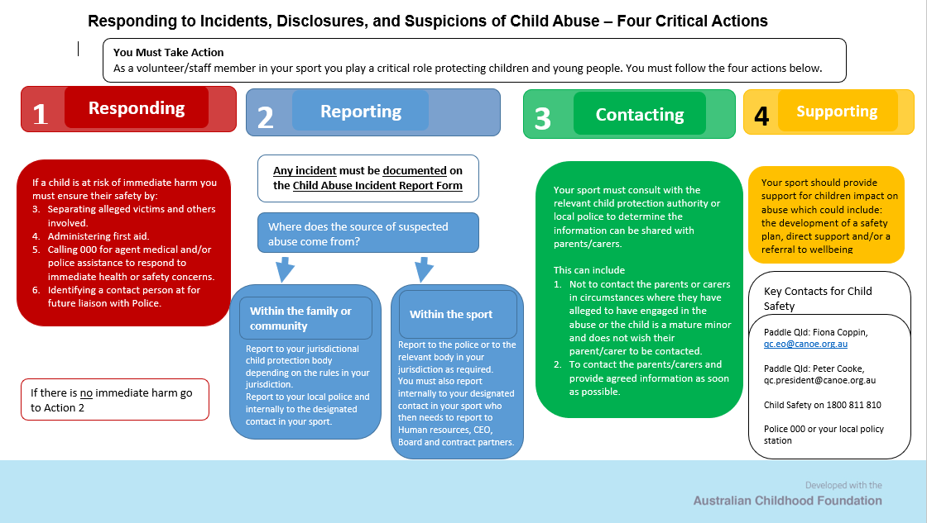

Submit Child Incident Report Form to the Club President:
2019: Steve McDonald: stephen.mcdonald@iinet.net.au

Appendix 2

Child Abuse Incident Report Form
[This form must be used to record details of a Child Abuse Incident or Allegation]

Child / Client Name:
Program:
Date of incident: |  |  | Site where incident occurred:
Person making Report: |  |  | Role & Relationship to Child:
Type of incident (tick all that apply):
☐ | Suspicion or allegation of abuse or neglect of client |  |  | ☐ | Serious breach of client confidentiality
☐ | Suspicion of potential harm to a client |  |  | ☐ | Serious breach of duty of care
☐ | Potential abuse by or criminal matters involving an employee |  |  | ☐ | A complaint
☐ | An episode of severe challenging behaviour |  |  | ☐ | A complaint involving legal proceedings
☐ | Potential harm to an employee resulting from harassment/bullying |  |  | ☐ | A serious incident as defined in the Incident Management policy
- Details of the child / young person affected by the incident
- [A Separate Child Abuse Incident Report Form should be completed for each child]
- Full name
- Date of birth |  | - Gender
- Any communication or medical requirements
- Parent / guardian name
- Parent / guardian contact/s phone | - (Home)  - (Mobile) |  | - (Work)
- Parent / guardian address
- Any known parent / guardian communication requirement

- Details of other persons involved
- Alleged perpetrator(s) details:
- Name – if known.
- Connection with the child – if known
- Any other relevant factors:
- Were there any other witnesses to the incident? Yes No
- If yes, please provide their details below:
- Full name
- Involvement as witness
- Contact phone number
- Full name
- Involvement as witness
- Contact phone number
- Details of incident
- (Please describe the incident including alleged perpetrator/s behaviour, sighted injury or other indicators of abuse, conversations with the child)

- Action undertaken (if any):
- To ensure the safety of child/client:
- To address the support needs of the child / client and their family:
- To address the support needs of the alleged perpetrator:
- To address the support needs of other staff and volunteers involved:
- Incident response
- Please tick who of the following have been informed of this incident:
- Externally | - Police Child Protection Ambulance Doctor Family / Carer  - Other (please specify) ____________________________
- Internally | - Manager (please specify):  - Please note that a Manager must be informed
- Police
- Date: |  | - Time:
- Name of person notified: |  | - Position:
- Department / region: |  | - Contact detail/s:
- Advice provided:

- Child Protection
- Date: |  | - Time:
- Name of person notified: |  | - Position:
- Department / region: |  | - Contact detail/s:
- Advice provided:

- Parent / guardian
- Has the parent been informed of the incident: Yes No
- (If appropriate) has the reporter been informed the authorities being notified: Yes No
- If yes, please provide relevant details of conversations: | - E.g. (information provided, reactions, concerns and admissions)
- If no, please explain why:

- Please provide details of which manager/s or other staff and volunteers has been informed of the incident?
- Full name:
- Position / title:
- Date and time informed:
- Full name
- Position / title:
- Date and time informed:

- Additional comments:
- Acknowledgement of form completion
- I have completed this form to the best of my knowledge and ability
- Name |  | - Position
- Signed |  | - Date
- Supervisor
- I have checked that all sections of this form are complete
- Name |  | - Position
- Signed |  | - Date

Privacy Disclaimer:
The West End Canoe Club acknowledges and respects the privacy of all its staff, volunteers, contractors and patrons. The information being collected is for the purposes of obtaining details of and assessing the incident in question. Information disclosed on this form may be passed on to the appropriate authorities, as required. By signing this form, you have consented to this information being collected, used and disclosed for the purposes it intended. You have the right to access and alter personal information concerning yourself in accordance with the Commonwealth Privacy Act (amended 2001).

Submit Child Incident Report Form to the Club President:
2019: Steve McDonald: stephen.mcdonald@iinet.net.au

Appendix 3.
Risk Assessment for Kayaking/Canoeing.
NB. WECC does not have a junior membership category. Kayaking/Canoeing is inherently dangerous. Member’s children may be in attendance at Club activities and should be under the close supervision of their parents.
This is not a complete Risk Assessment. Club members considering bringing their children to events near the water should make their own assessment about safety.

Description of Activity | Risks | Likelihood | Consequence | Risk Level | Causal Factors |  | Risk Management Strategy | Review Person
Children attend the club house before or after paddling events. | Drowning | Possible | Critical | High | People | Children unable to swim,  Inadequate parental supervision | Parents to supervision children at all times
 |  |  |  |  | Environ-ment | Strong current, deep water,
 | Injury | Possible | Minor-Major | Moderate | People | Children not aware of dangers of paddling equipment and storage, inadequate parental supervision | Parents to supervision children at all times, children not to enter storage shed.

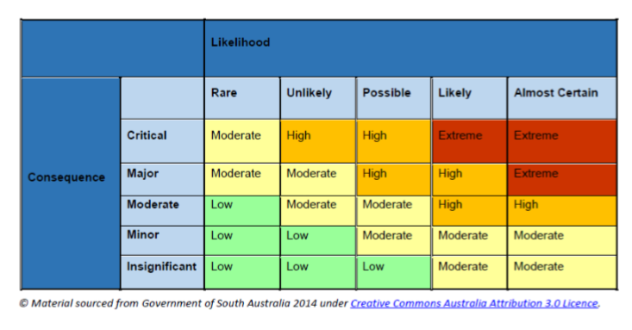

Version: February 2019. Approved by Paddle Qld CEO 11.2.19.

